Day 26 22 Aug 2025

Task 1: Strategy Method Design pattern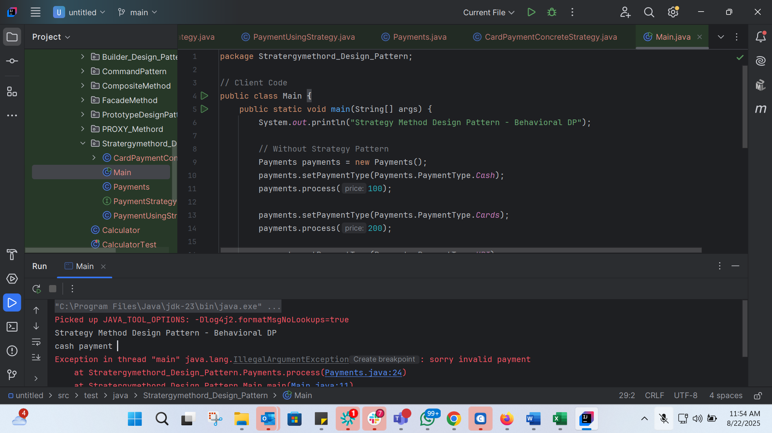

Task 2: Pub Sub Pattern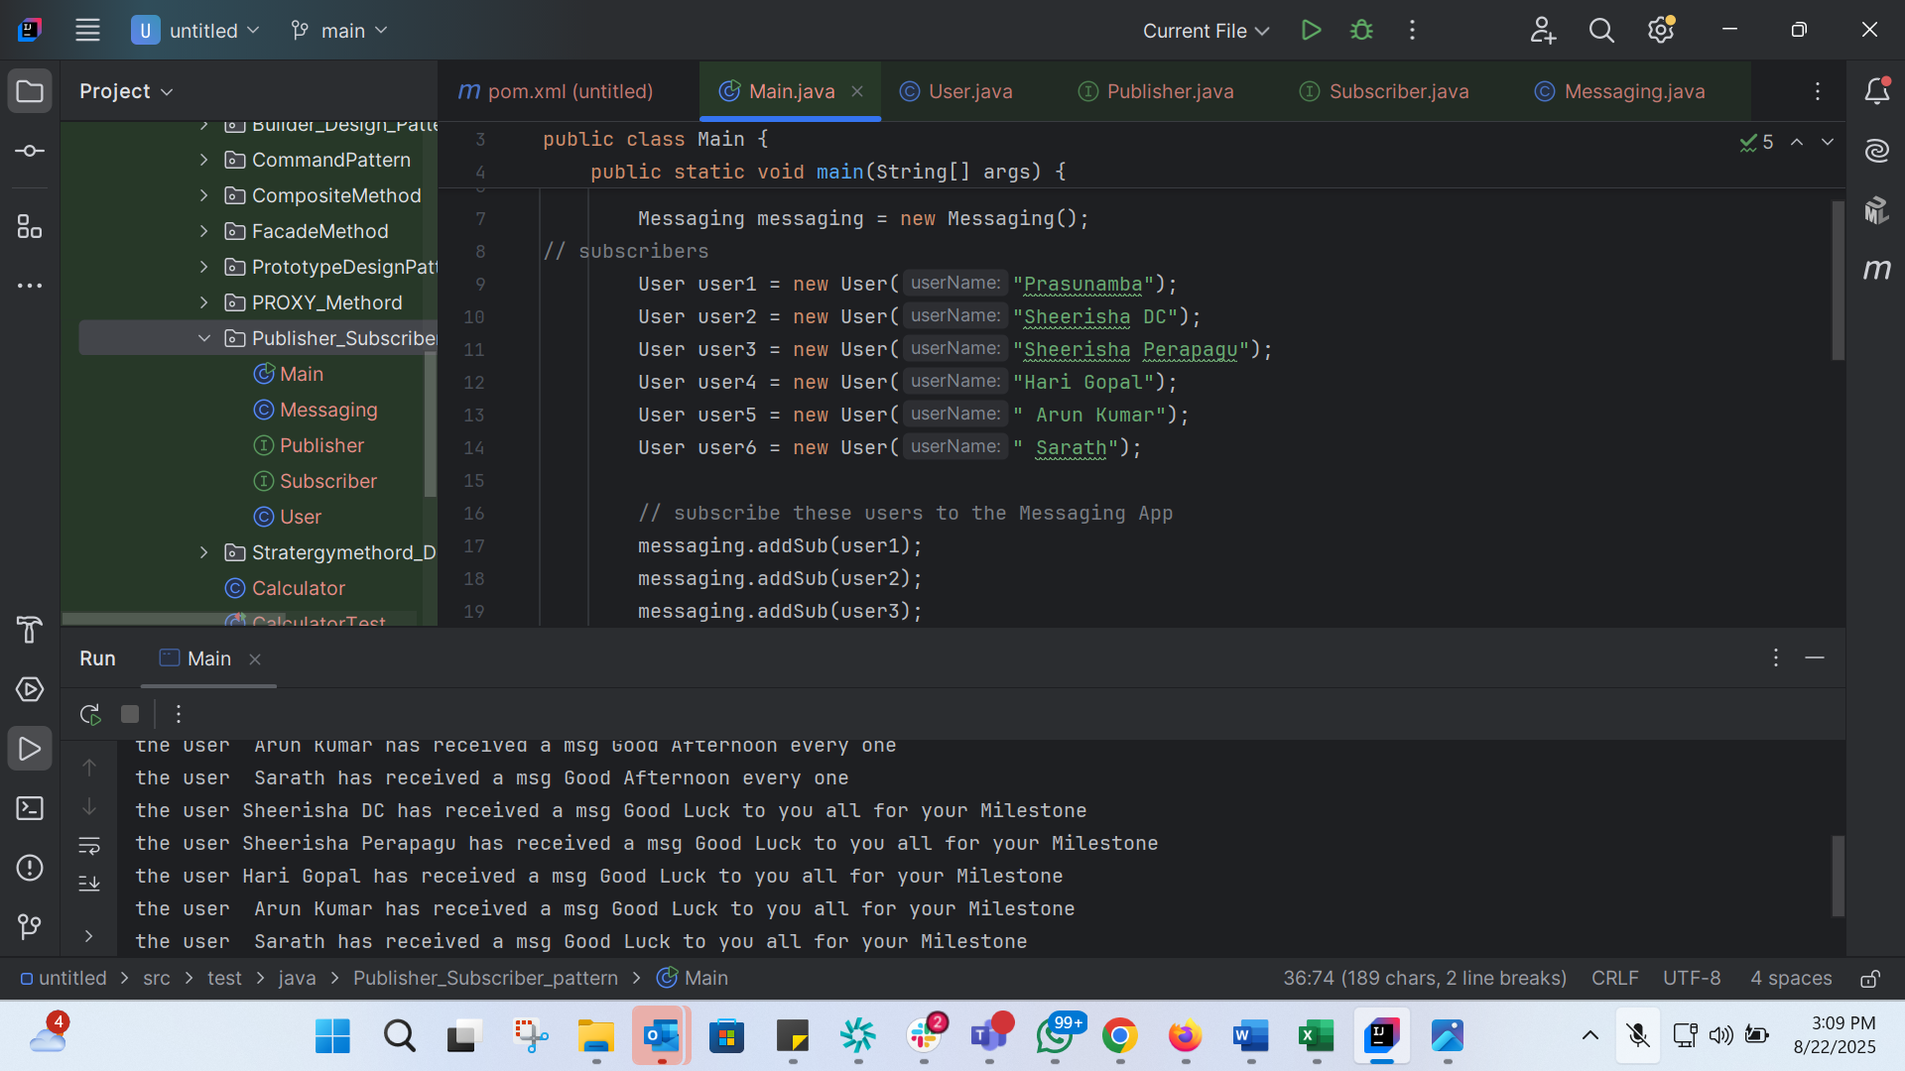
Task 3:
What do you understand by Design Work Flow?
Design workflow refers to the process of planning, creating, and implementing a design solution. It's a structured approach to designing products, systems, or experiences that involves several stages, from research and concept development to testing and iteration.
Stages of Design Workflow
- Research: Gathering information and understanding the problem or opportunity.
- Define: Defining the problem or opportunity and identifying the design goals.
- Ideate: Generating ideas and concepts.
- Prototype: Creating a tangible representation of the design solution.
- Test: Testing the design solution with users or stakeholders.
- Iterate: Refining the design solution based on feedback and test results.
By following a design workflow, designers can create effective and user-friendly solutions that meet the needs of their users.

Task 4: What is persistence objects?
A persistent object is an object in a program that represents data stored in a permanent storage, such as a database, and whose state can outlive the application process.

In Java, objects are usually created in memory, and when the program ends, they disappear. But if an object is connected to a persistence mechanism, like Hibernate/JPA, and stored in a database, it becomes a persistent object.

For example, consider a Student object with fields like id, name, and course. If we simply create it with new, it exists only in memory (that’s a transient object). But once we save it through Hibernate’s EntityManager.persist() method, it is stored in the database and becomes a persistent object. Even if the application restarts, we can retrieve it again using its ID.

So, the key idea is: a persistent object is not just in memory — its state is also synchronized with a database or storage system.

Task 4:

Which of the following components is not typically part of the Command pattern?
a) Invoker
b) Receiver
c) Abstract Factory
d) Command (interface/abstract class)

Task 5:

What role does the Invoker play in the Command pattern?
a) It knows how to perform the operations associated with a request.
b) It encapsulates the request as an object.
c) It asks the command to carry out the request.
d) It defines the interface for executing an operation.
Task 6:
A key benefit of using the Command pattern is its ability to support:
a) Lazy initialization
b) Undo/Redo functionality
c) Singleton instance creation
d) Compile-time polymorphism
Task 7:
In the Strategy pattern, what role does the "Context" play?
A. It defines the interface for the algorithms.
B. It implements a specific algorithm.
C. It maintains a reference to a Strategy object and delegates the task to it.
D. It creates the Concrete Strategy objects.
Task 8:
In which of the following mechanisms, types of all variables and expressions are fixed at compilation time.
a) Strong Typing
b) Weak Typing
c) Static Binding/ early binding
d) Dynamic Binding/ late binding
Task 9:

In which pattern does a class represent the functionality of another class, providing a simplified interface to a complex subsystem?
a) Decorator Pattern
b) Facade Pattern
c) Proxy Pattern
d) Composite Pattern

Task 10:

Which of the following statements about Persistence is correct?
a) It is the enforcement of the class of an object, such that objects of different types may not be interchanged, or at the most they may be interchanged only in very restricted ways.
b) It is the property of an object through which its existence transcends time and/or space.
c) It is the property that distinguishes an active object from one that is not active.
d) All of the mentioned

Task 11:

What is that concept in type theory in which a single name may denote objects of many different classes that are related by some common super class referred to ______
a) Monomorphism
b) Type Checking
c) Polymorphism
d) Generalization
Task 12:

Which of the following patterns is used to create a single instance of a class and provide a global point of access to it?

a) Factory Pattern
b) Singleton Pattern
c) Builder Pattern
d) Prototype Pattern

Task 13:

The Adapter pattern is a type of ______ pattern.
a) Creational
b) Structural
c) Behavioral
d) Concurrency

Task 14:

Which design pattern defines a one-to-many dependency between objects so that when one object changes state, all its dependents are notified and updated automatically?
a) Strategy Pattern
b) Command Pattern
c) Observer Pattern
d) Mediator Pattern

Task 15:

The Model-View-Controller (MVC) is an example of a ______ pattern.
a) Creational
b) Structural
c) Behavioral
d) Architectural
Task 16:
